Create a table for Employee as follows:

|  |  |  |  |  |  |
| --- | --- | --- | --- | --- | --- |
| EMPID | NAME | COUNTRY | SALARY | JOINING_DATE | DEPARTMENT |
| 001 | Shippy | Jamaica | 100000 | 2022-02-20 09:00:00 | S/W Engg-A |
| 002 | Christopher | Jamaica | 800000 | 2022-06-11 09:00:00 | S/W Engg |
| 003 | ALANZO | India | 300000 | 2022-02-20 09:00:00 | S/W Engg |
| 004 | Ezra | Jamaica | 500000 | 2022-02-20 09:00:00 | S/W Engg-C |
| 005 | Grant | India | 500000 | 2022-06-11 09:00:00 | S/W Engg |
| 006 | Olando | Jamaica | 200000 | 2022-06-11 09:00:00 | S/W Engg |
| 007 | CAMI | India | 705000 | 2022-01-20 09:00:00 | S/W Engg-B |
| 008 | Donald | India | 900000 | 2022-04-11 09:00:00 | S/W Engg |

DROP TABLE IF EXISTS Employee;

CREATE TABLE Employee

(

EMPID INT PRIMARY KEY NOT NULL,

NAME VARCHAR(50) NOT NULL,

COUNTRY VARCHAR(50) NOT NULL,

SALARY DECIMAL(8,2) NOT NULL,

JOINING_DATE DATETIME NOT NULL,

DEPARTMENT VARCHAR(50) NOT NULL

);

-- CREATING ANOTHER TABLE - Employee_personal

-- Question 16 - Create a table Employee_personal

DROP TABLE IF EXISTS Employee_personal;

CREATE TABLE Employee_personal

(

EMPID INT PRIMARY KEY NOT NULL,

NAME VARCHAR(50) NOT NULL,

PLACE VARCHAR(50) NOT NULL,

GENDER VARCHAR(50) NOT NULL,

AVAILABLE VARCHAR(50) NOT NULL,

PHNO VARCHAR(50) NOT NULL,

DEPARTMENT VARCHAR(50) NOT NULL

);

INSERT INTO

Employee

(EMPID, NAME, COUNTRY, SALARY, JOINING_DATE, DEPARTMENT)

VALUES

(001, 'Shippy', 'Jamaica', 100000, '2022-02-20 09:00:00', 'S/W Engg-A'),

(002, 'Christopher', 'Jamaica', 800000, '2022-06-11 09:00:00', 'S/W Engg'),

(003, 'Alanzo', 'India', 300000, '2022-02-20 09:00:00', 'S/W Engg'),

(004, 'Ezra', 'Jamaica', 500000, '2022-02-20 09:00:00', 'S/W Engg-C'),

(005, 'Grant', 'India', 500000, '2022-06-11 09:00:00', 'S/W Engg'),

(006, 'Olando', 'Jamaica', 200000, '2022-06-11 09:00:00', 'S/W Engg'),

(007, 'Camille', 'India', 705000, '2022-01-20 09:00:00', 'S/W Engg-B'),

(008, 'Donald', 'India', 900000, '2022-04-11 09:00:00', 'S/W Engg');

INSERT INTO

Employee_personal

(EMPID, NAME, PLACE, GENDER, AVAILABLE, PHNO, DEPARTMENT)

VALUES

(001, 'Shippy', 'Kingston', 'Male', 'Yes', '(876) 987-8346', 'S/W Engg-A'),

(002, 'Christopher', 'Montego Bay', 'Male', 'No', '(876) 785-6346', 'S/W Engg'),

(003, 'Alanzo', 'New Delhi', 'Male', 'Yes', '(876) 864-5346', 'S/W Engg'),

(004, 'Ezra', 'Saint James', 'Male', 'Yes', '(876) 879-5346', 'S/W Engg-C'),

(005, 'Grant', 'Chennai', 'Male', 'No', '(876) 956-8346', 'S/W Engg'),

(006, 'Olando', 'Portmore', 'Male', 'Yes', '(876) 849-4346', 'S/W Engg'),

(007, 'Camille', 'Coimbatore', 'Female', 'No', '(876) 987-5346', 'S/W Engg-B'),

(008, 'Donald', 'Udumalper', 'Male', 'No', '(876) 895-4346', 'S/W Engg');

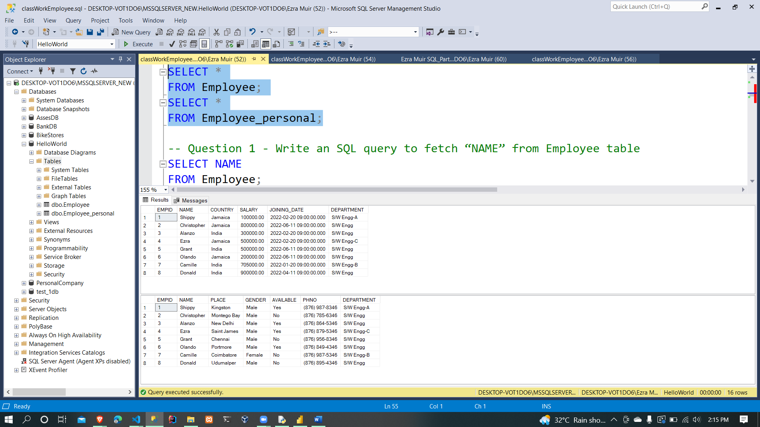

1. Write an SQL query to fetch “NAME” from Employee table

SELECT NAME

FROM Employee;

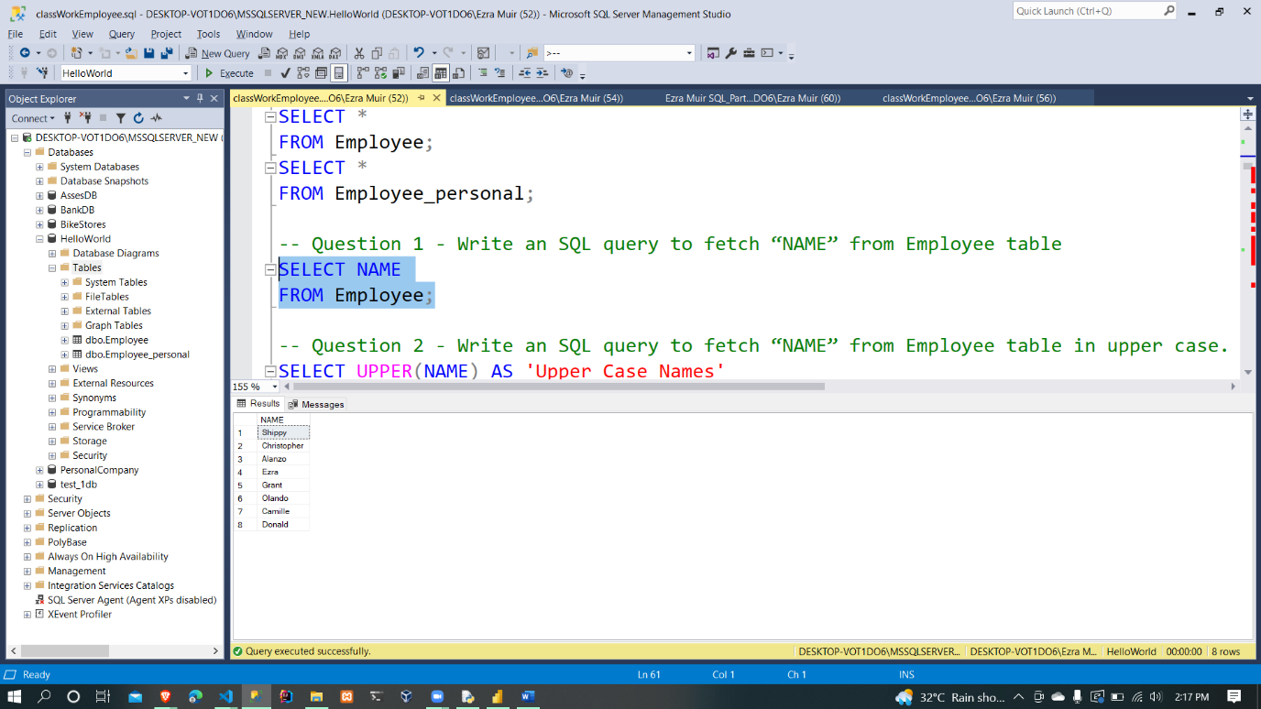

1. Write an SQL query to fetch “NAME” from Employee table in upper case.

SELECT UPPER(NAME) AS 'Upper Case Names'

FROM Employee;

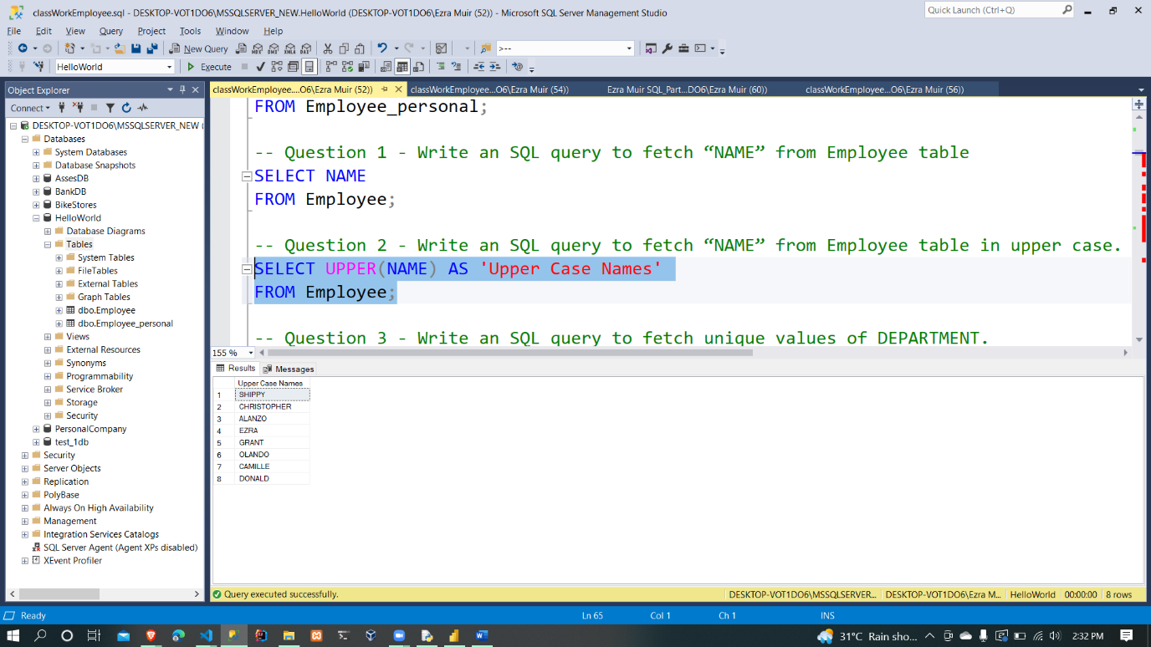

1. Write an SQL query to fetch unique values of DEPARTMENT.

SELECT DISTINCT DEPARTMENT

FROM Employee;

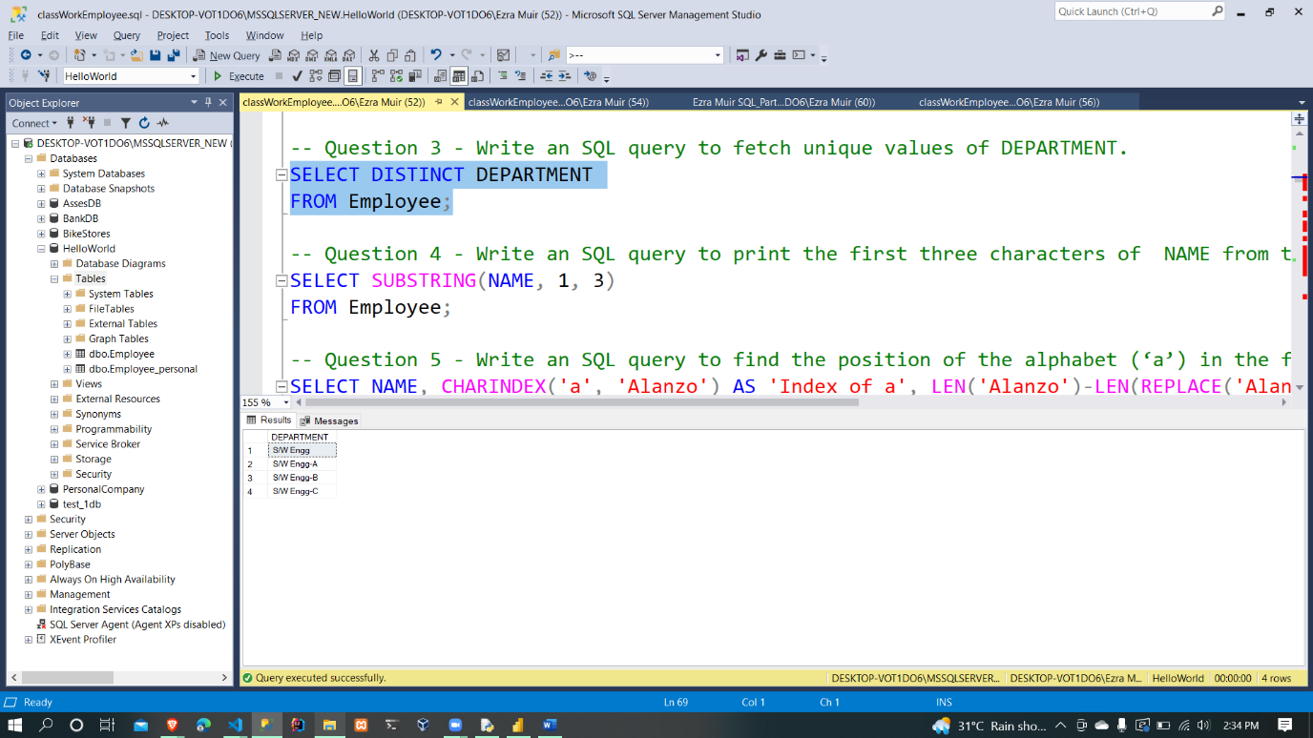

1. Write an SQL query to print the first three characters of  NAME from table.

SELECT SUBSTRING(NAME, 1, 3)

FROM Employee;

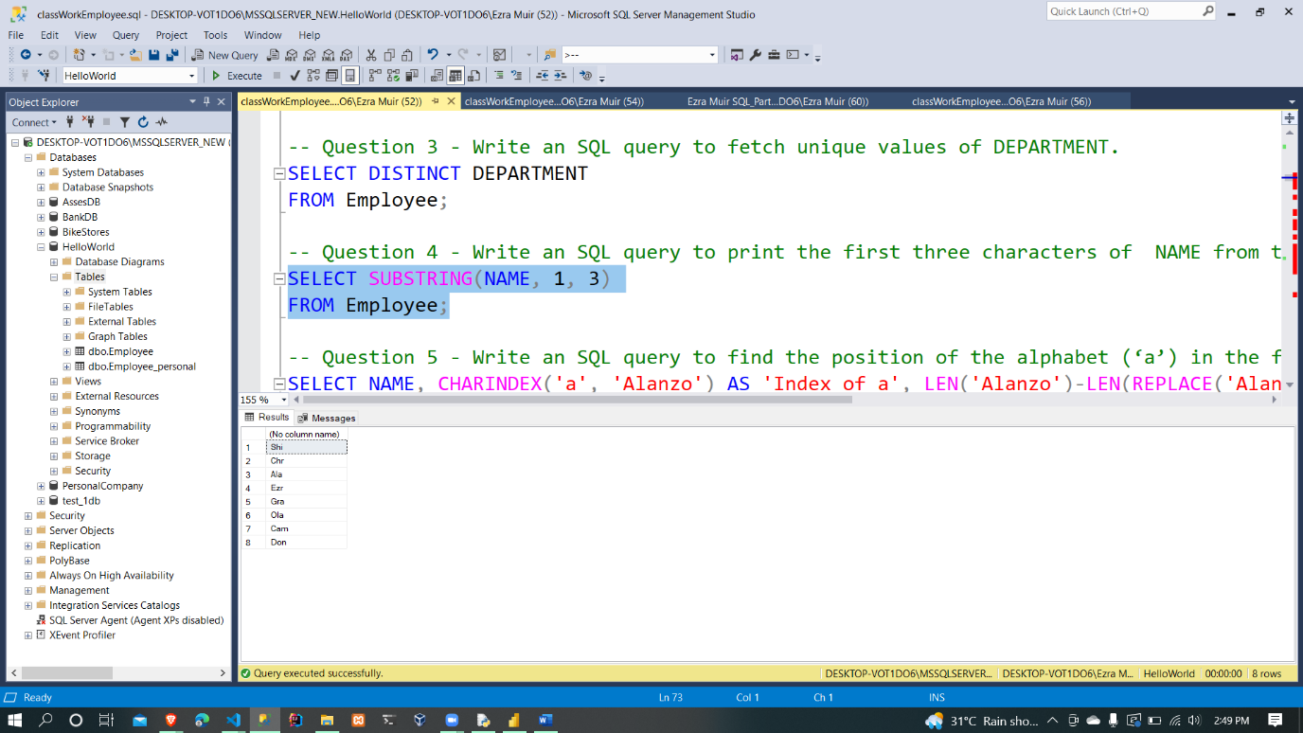

1. Write an SQL query to find the position of the alphabet (‘a’) in the first name column ‘Ezra from the table.

SELECT NAME, CHARINDEX('a', 'Ezra') AS 'Position At'

FROM Employee

WHERE NAME='Ezra';

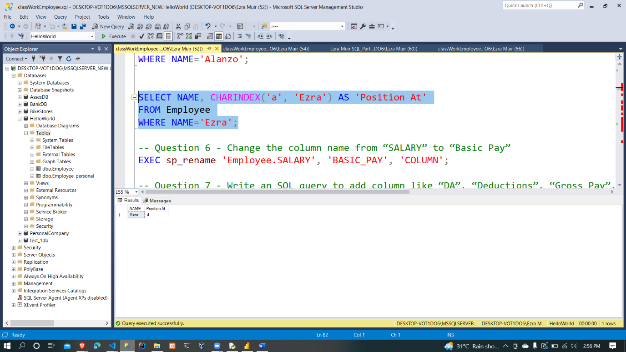

1. Change the column name from “SALARY” to “Basic Pay”

EXEC sp_rename 'Employee.SALARY', 'BASIC_PAY', 'COLUMN';

1. Write an SQL query to add column like “DA”, “Deductions”, “Gross Pay”, “Net Pay”.

ALTER TABLE Employee

ADD DA DECIMAL(8,2),

DEDUCTIONS DECIMAL(8,2),

GROSS_PAY DECIMAL(8,2),

NET_PAY DECIMAL(8,2);

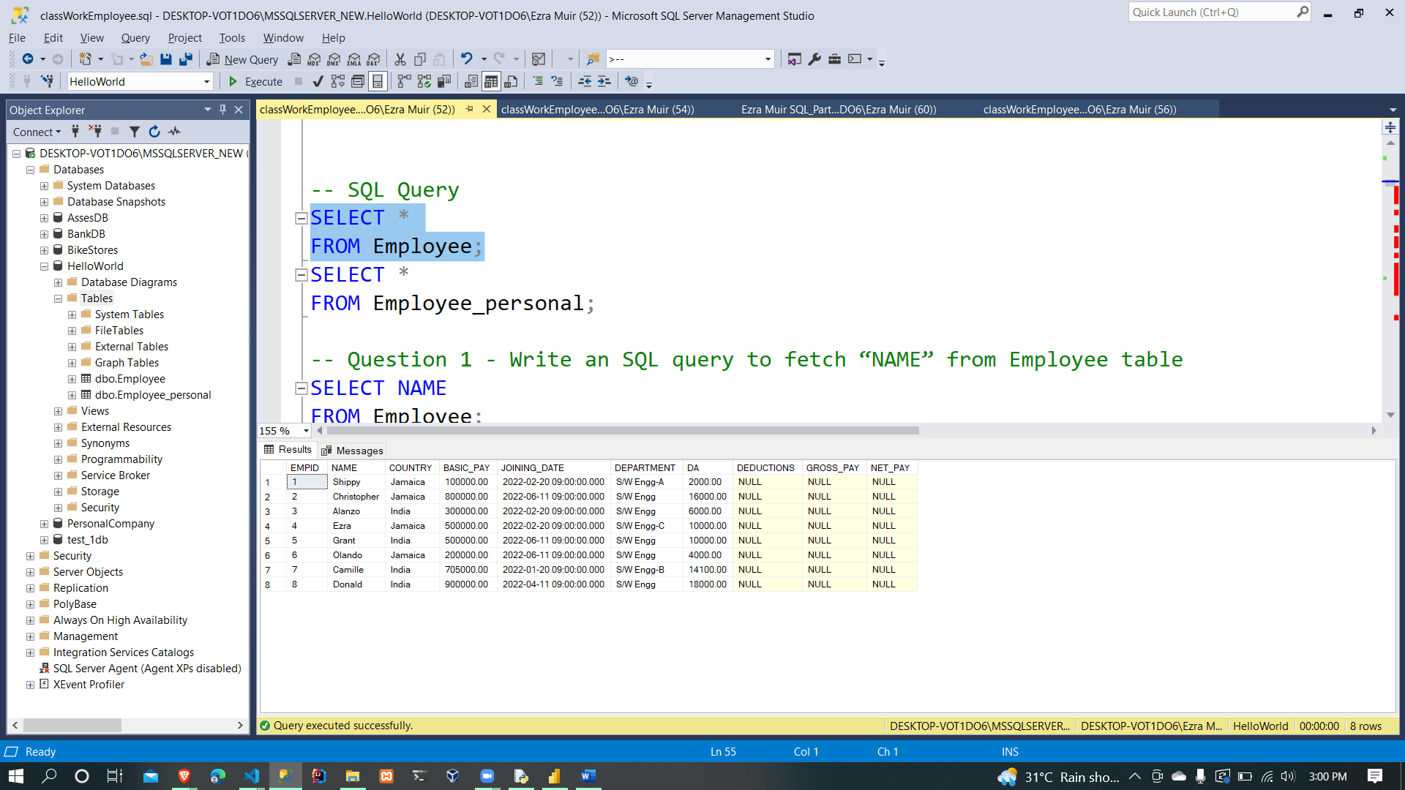

1. DA = 2% of Basic Pay

UPDATE Employee

SET DA = 0.02 * BASIC_PAY;

1. Deductions = 3% of Basic Pay

UPDATE Employee

SET DEDUCTIONS = 0.03 * BASIC_PAY;

1. Gross Pay =Basic Pay + DA

UPDATE Employee

SET GROSS_PAY = BASIC_PAY + DA;

1. Net Pay = Gross Pay - Deductions

UPDATE Employee

SET NET_PAY = GROSS_PAY - DEDUCTIONS;

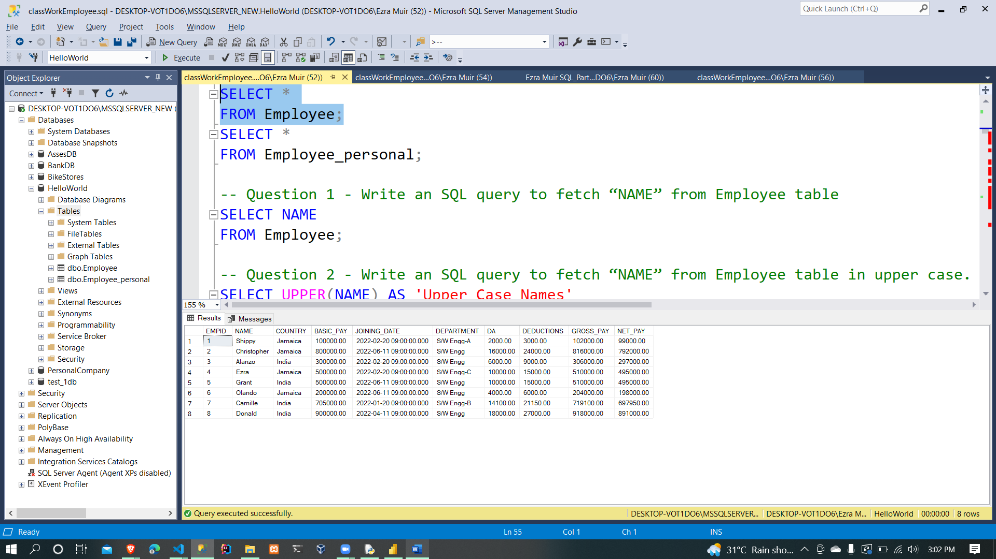

1. Display highest paid employee name

SELECT NAME, NET_PAY

FROM Employee

WHERE NET_PAY = (SELECT MAX(NET_PAY)

FROM Employee);

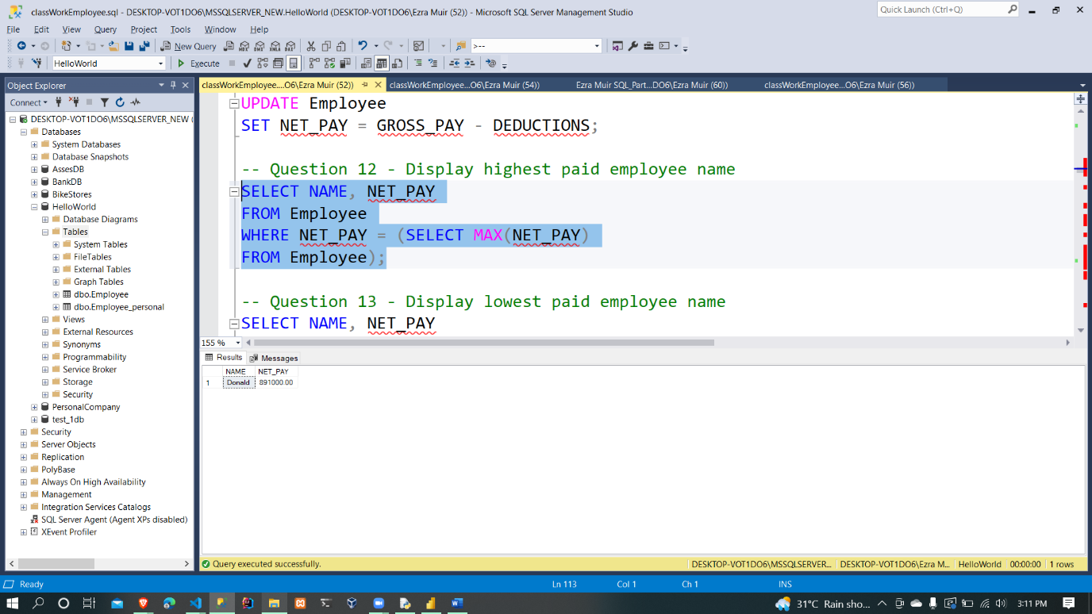

1. Display lowest paid employee name

SELECT NAME, NET_PAY

FROM Employee

WHERE NET_PAY = (SELECT MIN(NET_PAY)

FROM Employee);

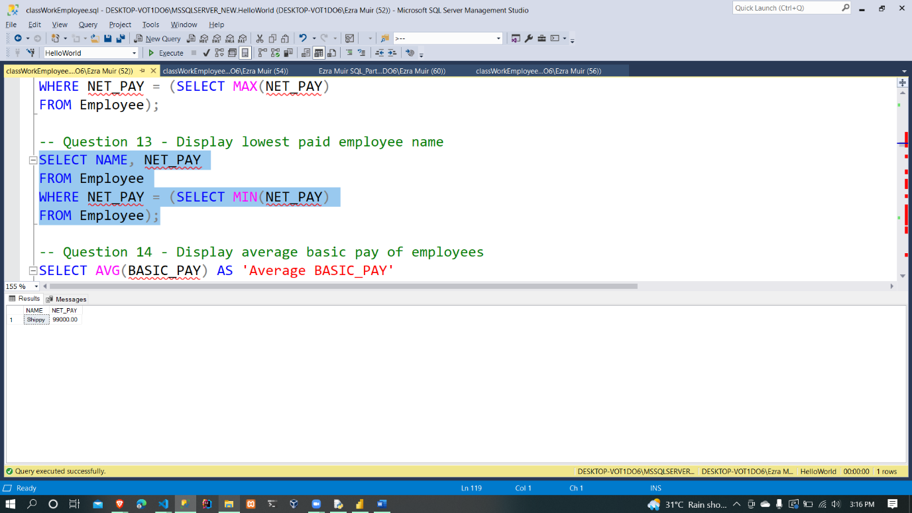

1. Display average basic pay of employees

SELECT AVG(BASIC_PAY) AS 'Average BASIC_PAY'

FROM Employee;

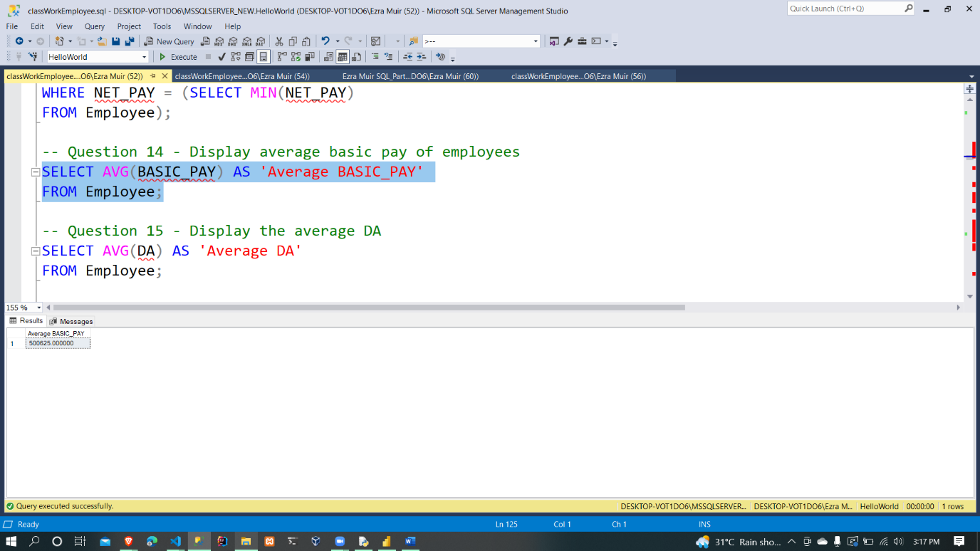

1. Display the average DA

SELECT AVG(DA) AS 'Average DA'

FROM Employee;

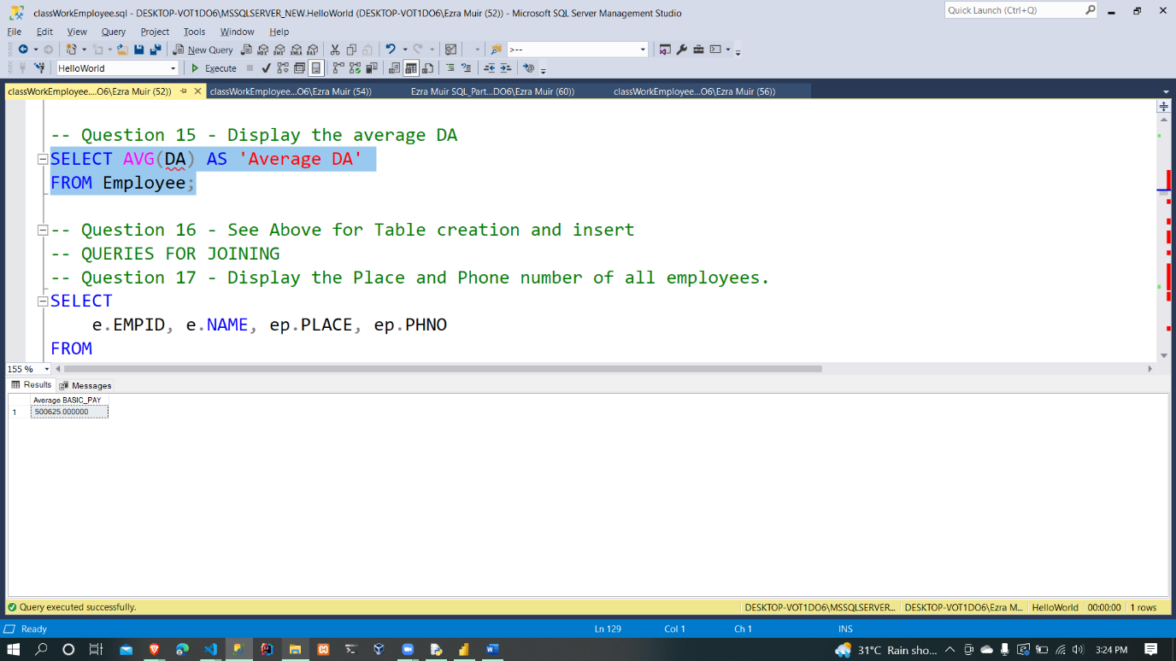

1. Create a table Employee_personal

|  |  |  |  |  |  |  |
| --- | --- | --- | --- | --- | --- | --- |
| EMPID | NAME | PLACE | GENDER | AVAILABLE | Phno | DEPARTMENT |
| 001 | Shippy | Kingston | Male | Yes | 9878 | S/W Engg-A |
| 002 | Christopher | Montego Bay | Male | No | 7856 | S/W Engg |
| 003 | ALANZO | New Delhi | Male | Yes | 8645 | S/W Engg |
| 004 | Ezra | Saint James Parish | Male | Yes | 8795 | S/W Engg-C |
| 005 | Grant | Chennai | Male | No | 9568 | S/W Engg |
| 006 | Olando | Portmore | Male | Yes | 8494 | S/W Engg |
| 007 | CAMI | Coimbatore | Female | No | 9875 | S/W Engg-B |
| 008 | Donald | Udumalpet | Male | No | 8954 | S/W Engg |

1. Display the Place and Phone number of all employees.

SELECT

e.EMPID, e.NAME, ep.PLACE, ep.PHNO

FROM

Employee e

INNER JOIN Employee_personal ep

ON e.NAME = ep.NAME

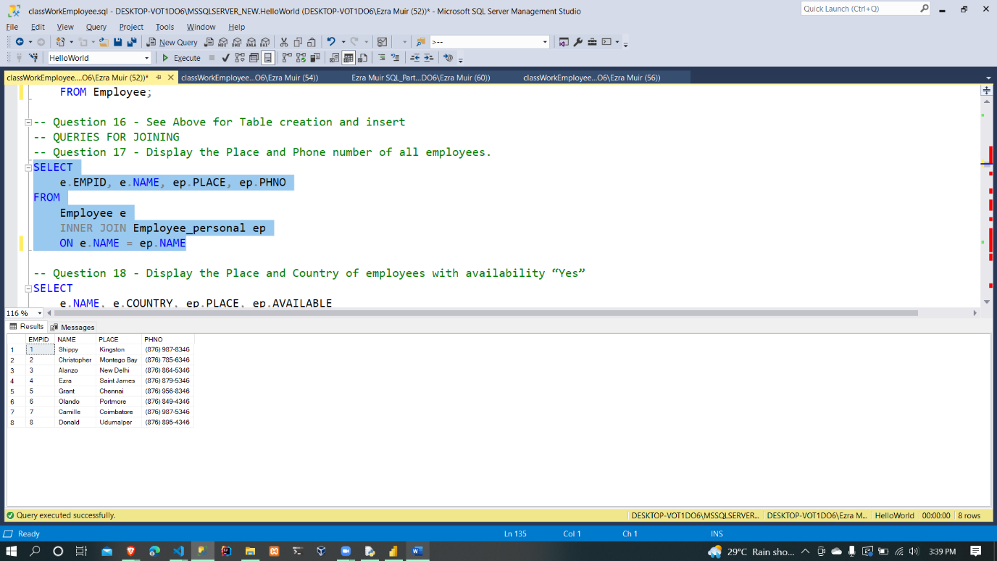

1. Display the Place and Country of employees with availability “Yes”

SELECT

e.NAME, e.COUNTRY, ep.PLACE, ep.AVAILABLE

FROM

Employee e

INNER JOIN Employee_personal ep

ON e.EMPID = ep.EMPID

WHERE

ep.AVAILABLE = 'Yes'

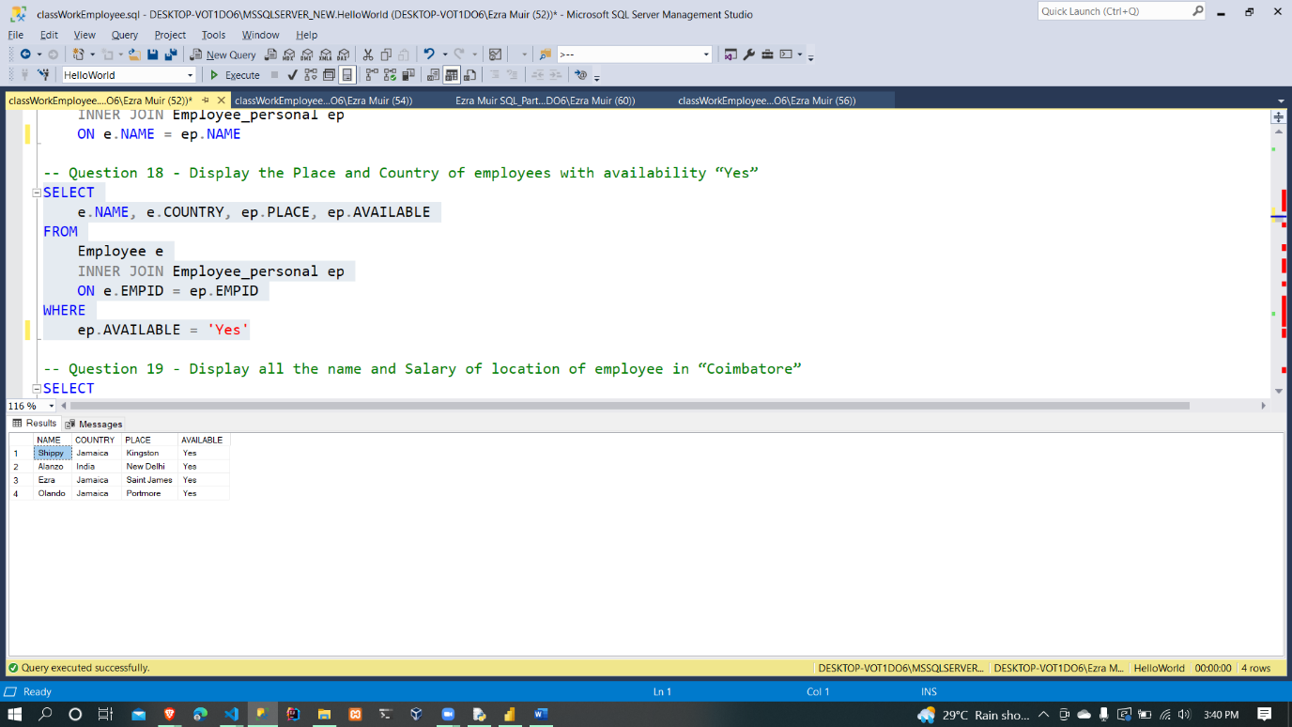

1. Display all the name and Salary of location of employee in “Coimbatore”

SELECT

e.NAME, e.BASIC_PAY, e.DEPARTMENT, ep.PLACE

FROM

Employee e

INNER JOIN Employee_personal ep

ON e.EMPID = ep.EMPID

WHERE

ep.PLACE = 'Coimbatore'

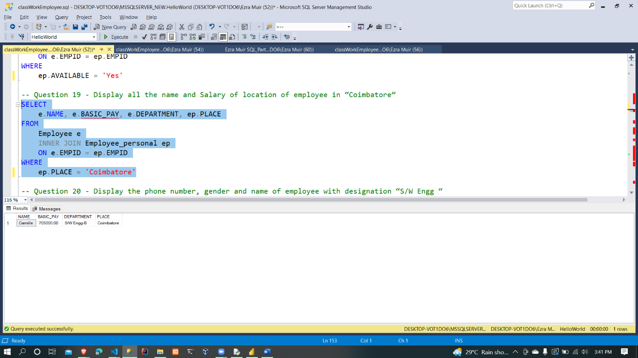

1. Display the phone number, gender and name of employee with designation “S/W Engg “

SELECT

e.NAME, ep.PHNO, ep.GENDER, e.DEPARTMENT

FROM

Employee e

INNER JOIN Employee_personal ep

ON e.NAME = ep.NAME

WHERE

e.DEPARTMENT = 'S/W Engg'

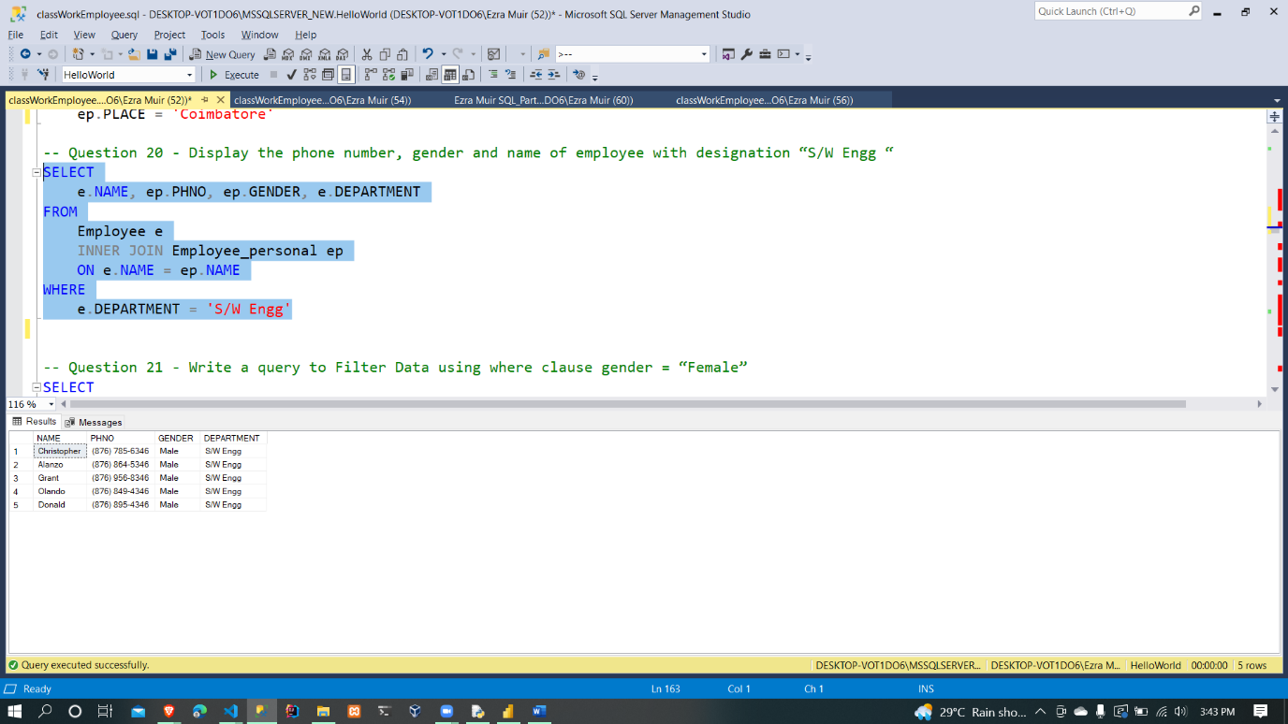

1. Write a query to Filter Data using where clause gender = “Female”

SELECT

NAME, GENDER

FROM

Employee_personal

WHERE

GENDER = 'Female';

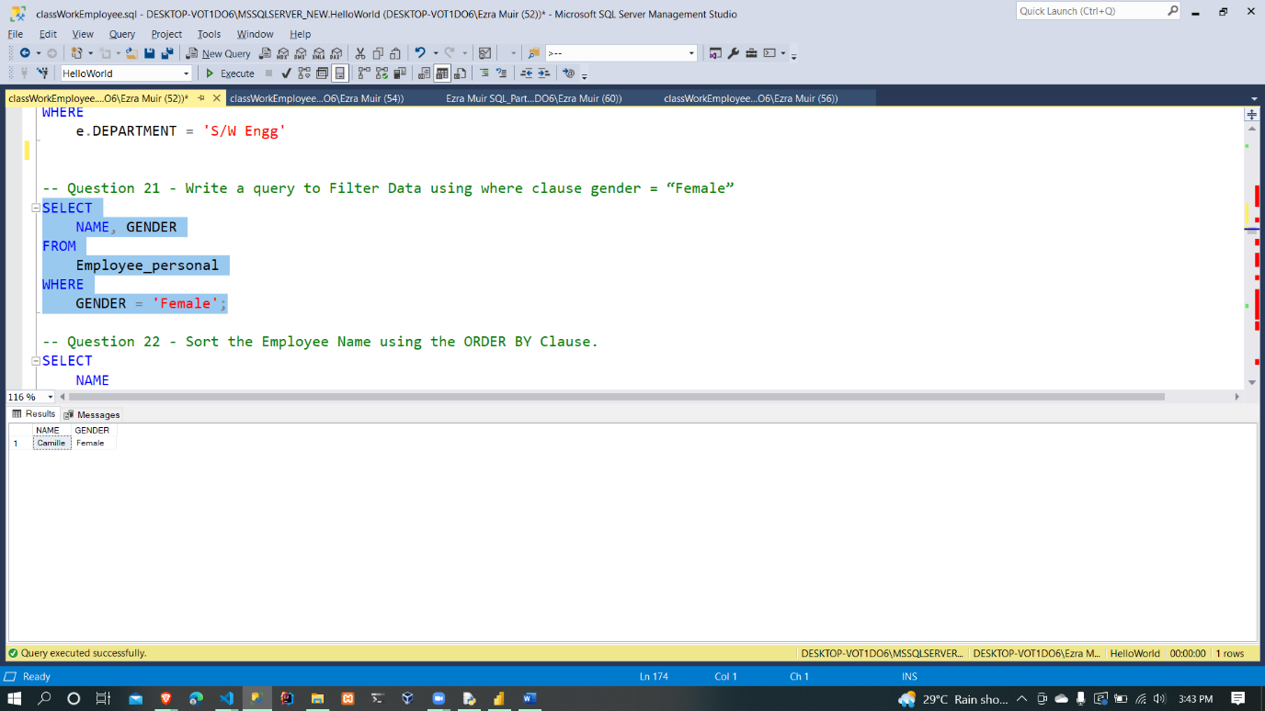

1. Sort the Employee Name using the ORDER BY Clause.

SELECT

NAME

FROM

Employee

ORDER BY NAME;

SELECT

NAME

FROM

Employee

ORDER BY NAME DESC;

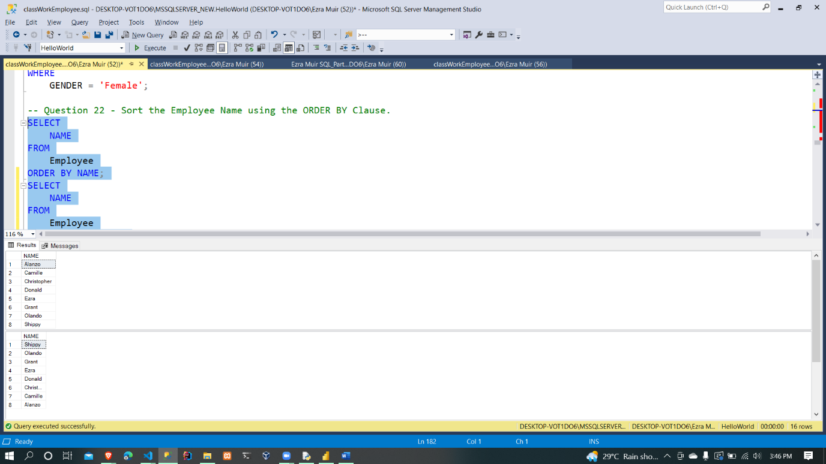

1. Display the TOP (5) high salaried employees – display their name, salary and department.

SELECT TOP 5

NAME, BASIC_PAY, DEPARTMENT

FROM

Employee

ORDER BY BASIC_PAY DESC;

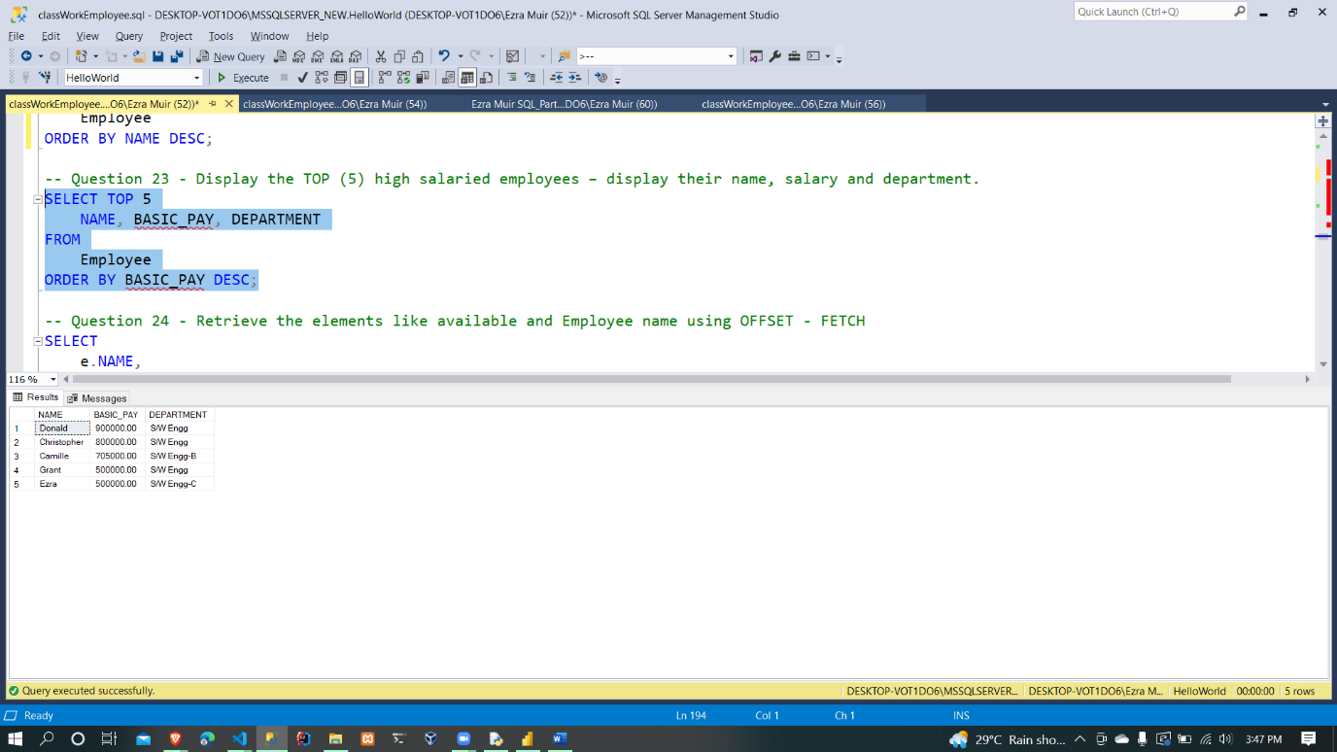

1. Retrieve the elements like available and Employee name using OFFSET – FETCH

SELECT

e.NAME,

ep.AVAILABLE

FROM

Employee e

FULL OUTER JOIN Employee_personal ep

ON e.NAME = ep.NAME AND e.EMPID = ep.EMPID

ORDER BY

e.NAME

OFFSET 4 ROWS

FETCH NEXT 4 ROWS ONLY;

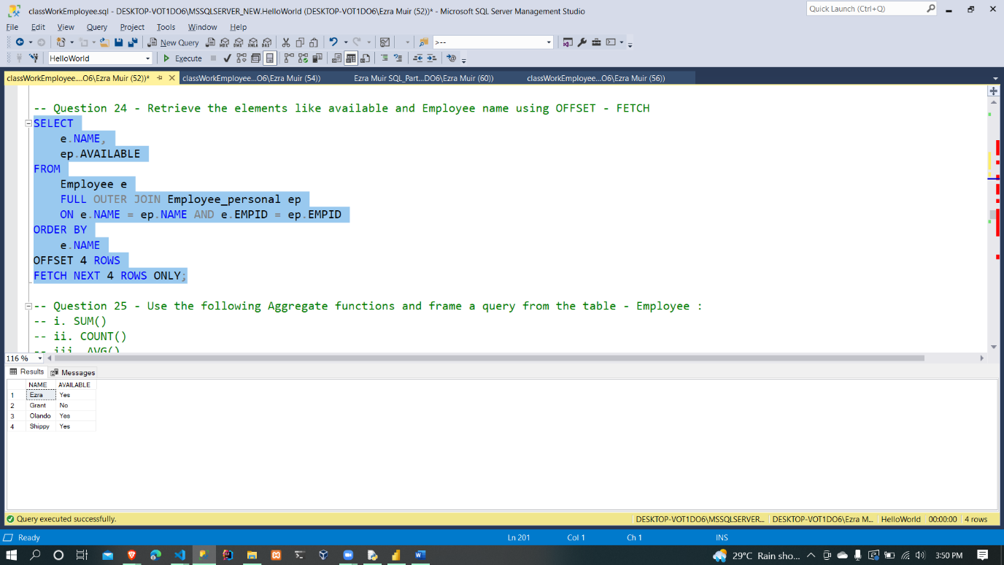

1. Use the following Aggregate functions and frame a query from the table - Employee :
   * 1. [SUM()](https://www.edureka.co/blog/sql-functions#sum)

SELECT SUM(BASIC_PAY) AS sum_of_basic_pay

FROM Employee;

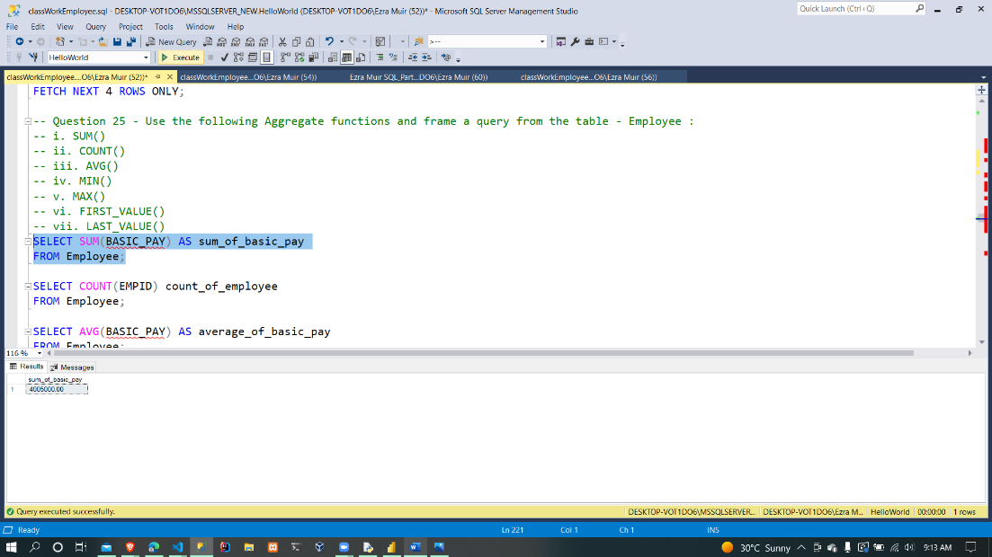

* + 1. [COUNT()](https://www.edureka.co/blog/sql-functions#count)

SELECT COUNT(EMPID) count_of_employee

FROM Employee;

* + 1. [AVG()](https://www.edureka.co/blog/sql-functions#avg)

SELECT AVG(BASIC_PAY) AS average_of_basic_pay

FROM Employee;

* + 1. [MIN()](https://www.edureka.co/blog/sql-functions#min)

SELECT MIN(BASIC_PAY) AS minimum_of_basic_pay

FROM Employee;

* + 1. [MAX()](https://www.edureka.co/blog/sql-functions#max)

SELECT MAX(BASIC_PAY) AS maximum_of_basic_pay

FROM Employee;

* + 1. [FIRST()](https://www.edureka.co/blog/sql-functions#first)

SELECT *,

FIRST_VALUE(BASIC_PAY) OVER (ORDER BY BASIC_PAY) AS first_value_of_basic_pay

FROM Employee;

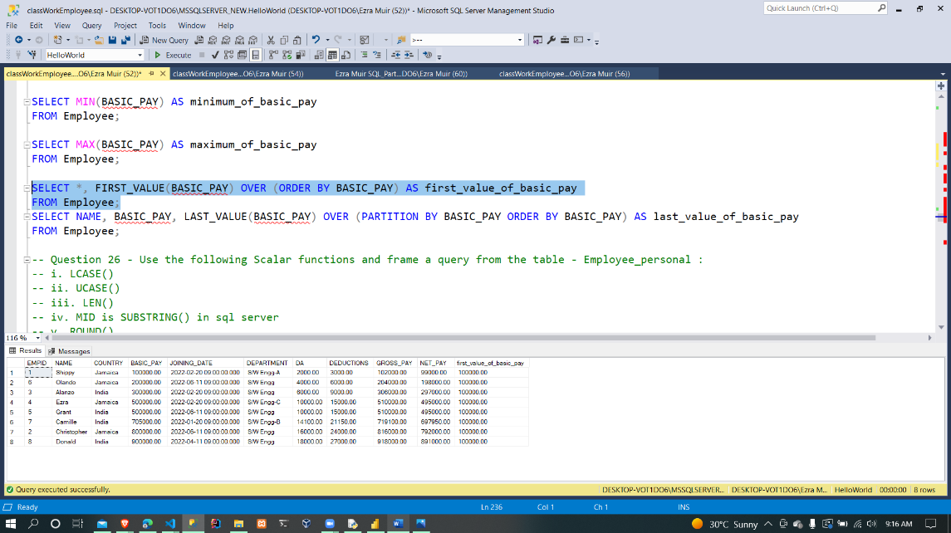

* + 1. [LAST()](https://www.edureka.co/blog/sql-functions#last)

SELECT NAME, BASIC_PAY,

LAST_VALUE(BASIC_PAY) OVER (PARTITION BY BASIC_PAY ORDER

BY BASIC_PAY) AS last_value_of_basic_pay

FROM Employee;

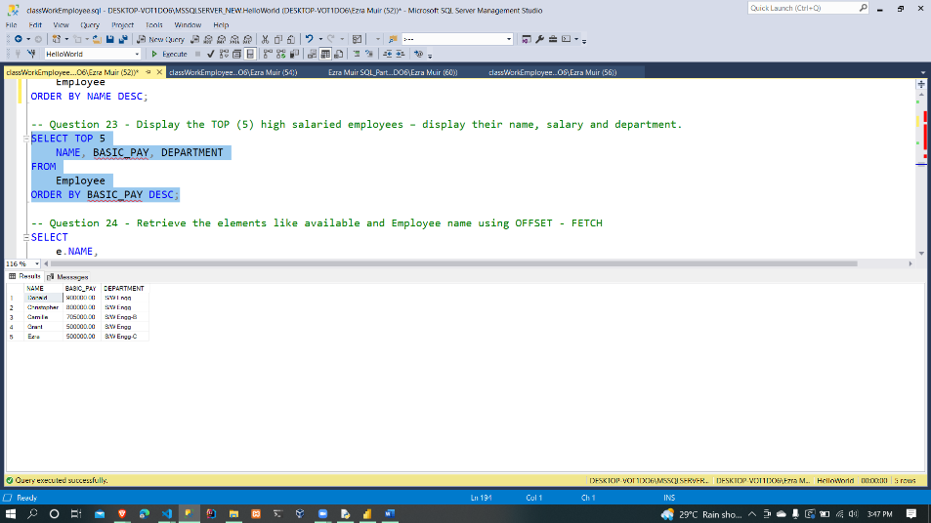

1. Use the following Scalar functions and frame a query - Employee_personal :
   * 1. [LCASE()](https://www.edureka.co/blog/sql-functions#lcase)

SELECT LOWER(NAME) AS upper_case_of_name

FROM Employee_personal;

* + 1. [UCASE()](https://www.edureka.co/blog/sql-functions#ucase)

SELECT UPPER(NAME) AS lower_case_of_name

FROM Employee_personal;

* + 1. [LEN()](https://www.edureka.co/blog/sql-functions#len)

SELECT NAME, LEN(NAME) AS length_of_name

FROM Employee_personal;

* + 1. [MID()](https://www.edureka.co/blog/sql-functions#mid)

SELECT NAME, SUBSTRING(NAME, 1, 4) AS substring_of_name

FROM Employee_personal;

* + 1. [ROUND()](https://www.edureka.co/blog/sql-functions#round)

SELECT AVG(e.BASIC_PAY) AS average_basic_pay,

ROUND(AVG(e.BASIC_PAY), 2) AS rounded_basic_pay

FROM Employee e

INNER JOIN Employee_personal ep

ON e.NAME = ep.NAME;

* + 1. [NOW()](https://www.edureka.co/blog/sql-functions#now)

SELECT SYSDATETIME() AS current_date_time

FROM Employee_personal

WHERE NAME = 'Ezra';

* + 1. [FORMAT()](https://www.edureka.co/blog/sql-functions#format)

SELECT FORMAT(SYSDATETIME(), 'dd-MM-yyyy hh:mm:ss') AS formatted_date_time

FROM Employee_personal;

1. Update the following columns to the table

Employee (i) (iii) and Employee_Personal (ii) (iii)

ALTER TABLE Employee_personal

ADD Rank INT,

Grade CHAR(1),

Project_Platform VARCHAR(50);

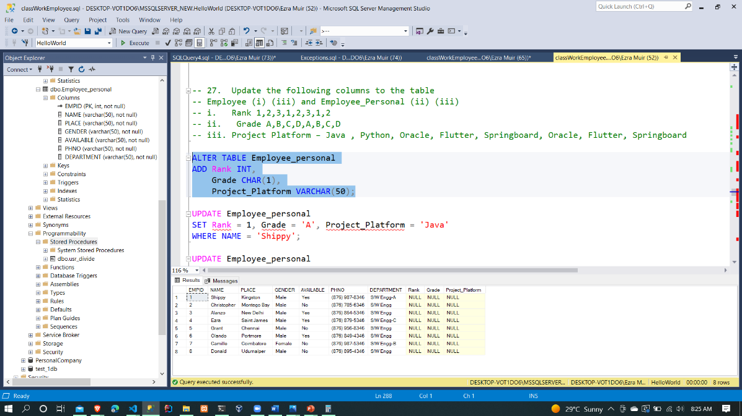

* + 1. Rank 1,2,3,1,2,3,1,2
    2. Grade A,B,C,D,A,B,C,D
    3. Project Platform – Java , Python, Oracle, Flutter, Springboard, Oracle, Flutter, Springboard

UPDATE Employee_personal

SET Rank = 1, Grade = 'A', Project_Platform = 'Java'

WHERE NAME = 'Shippy';

UPDATE Employee_personal

SET Rank = 2, Grade = 'B', Project_Platform = 'Python'

WHERE NAME = 'Christopher';

UPDATE Employee_personal

SET Rank = 3, Grade = 'C', Project_Platform = 'Oracle'

WHERE NAME = 'Alanzo';

UPDATE Employee_personal

SET Rank = 4, Grade = 'D', Project_Platform = 'Flutter'

WHERE NAME = 'Ezra';

UPDATE Employee_personal

SET Rank = 5, Grade = 'E', Project_Platform = 'Springboard'

WHERE NAME = 'Grant';

UPDATE Employee_personal

SET Rank = 6, Grade = 'F', Project_Platform = 'Oracle'

WHERE NAME = 'Olando';

UPDATE Employee_personal

SET Rank = 7, Grade = 'G', Project_Platform = 'Flutter'

WHERE NAME = 'Camille';

UPDATE Employee_personal

SET Rank = 8, Grade = 'H', Project_Platform = 'Springboard'

WHERE NAME = 'Donald';

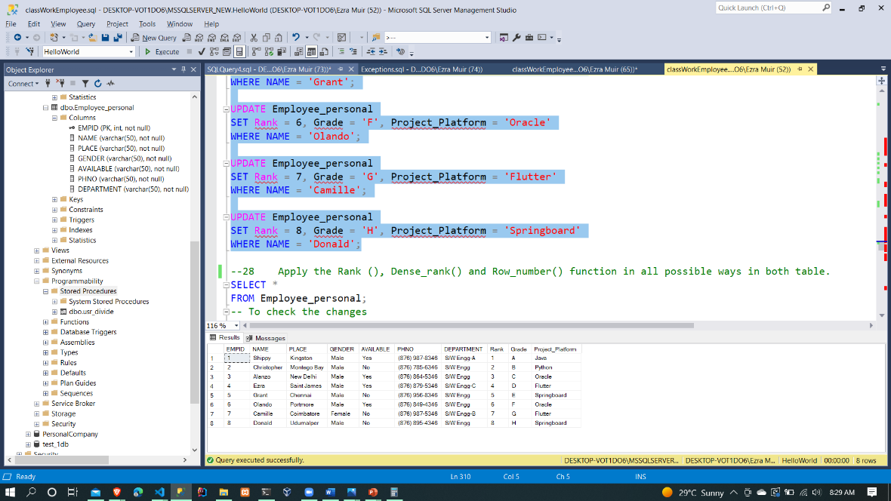

1. Apply the Rank (), Dense_rank() and Row_number() function in all possible ways in both table.

-- RANK()

SELECT

NAME, Rank, Grade, Project_Platform,

RANK() OVER (

ORDER BY Project_Platform

) AS rank_of_project_platform

FROM Employee_personal;

-- RANK() with OUTER JOIN

SELECT

ep.NAME, Rank, Grade, Project_Platform,

RANK() OVER (

PARTITION BY Project_Platform

ORDER BY Project_Platform

) AS rank_of_project_platform

FROM Employee_personal ep

FULL OUTER JOIN Employee e

ON ep.NAME = e.NAME;

-- DENSE_RANK()

SELECT

NAME, Rank, Grade, Project_Platform,

DENSE_RANK() OVER (

ORDER BY Project_Platform

) AS rank_of_project_platform

FROM Employee_personal;

-- ROW_NUMBER()

SELECT

NAME, Rank, Grade, Project_Platform, DEPARTMENT,

ROW_NUMBER() OVER (

PARTITION BY DEPARTMENT

ORDER BY NAME

) AS rank_of_row_number

FROM Employee_personal;

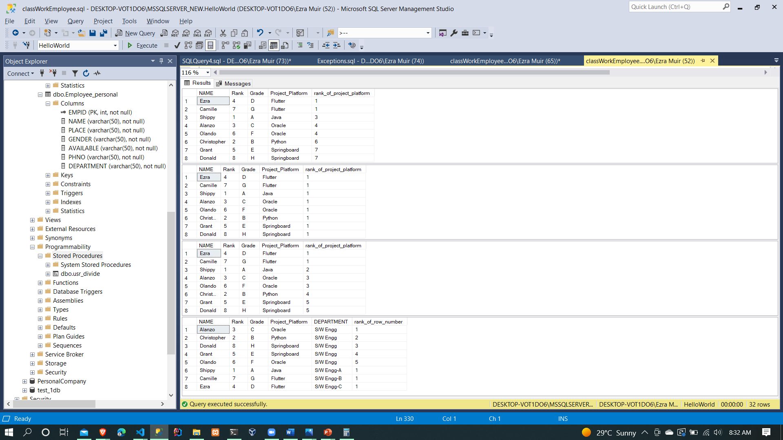

1. Implement the following Set Operators in both the tables (write syntax and example with existing tables)
   * 1. UNION
     2. UNION ALL
     3. INTERSECT
     4. MINUS

-- i. UNION

SELECT

EMPID, NAME, DEPARTMENT

FROM Employee

UNION

SELECT

EMPID, NAME, DEPARTMENT

FROM Employee_personal;

-- ii. UNION ALL

SELECT

EMPID, NAME, DEPARTMENT

FROM Employee

UNION ALL

SELECT

EMPID, NAME, DEPARTMENT

FROM Employee_personal;

-- iii. INTERSECT

SELECT

EMPID, NAME, DEPARTMENT

FROM Employee

INTERSECT

SELECT

EMPID, NAME, DEPARTMENT

FROM Employee_personal;

-- iv. MINUS (i.e. EXCEPT in sql server)

SELECT

EMPID, NAME, DEPARTMENT

FROM Employee

EXCEPT

SELECT

EMPID, NAME, DEPARTMENT

FROM Employee_personal;

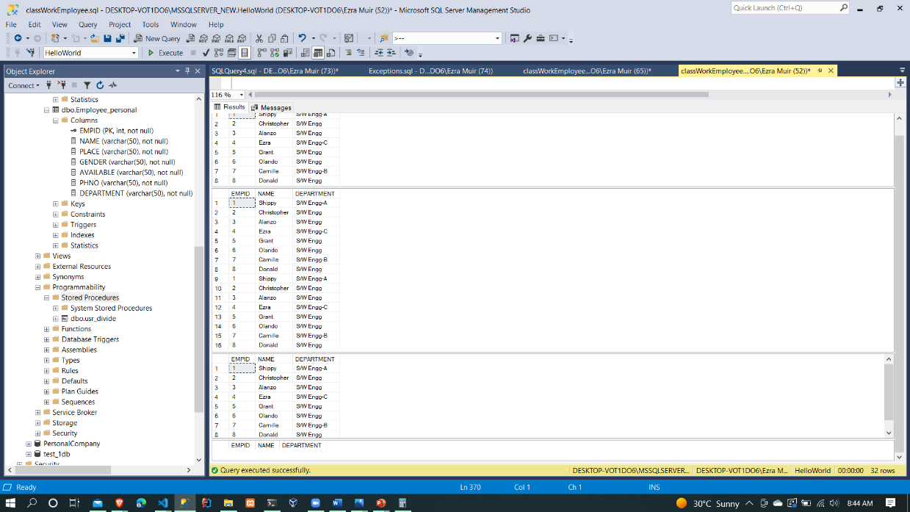

1. Self-Learn topics 1:
   * 1. Data manipulation in a database
     2. Need for data manipulation
     3. Transaction
2. Self-Learn topics (write the concept, syntax and example with existing tables) 2:
   1. COMMIT & ROLLBACK statements
   2. Using the SAVEPOINT statement
   3. Automatic COMMIT behaviour in SQL
   4. MERGE statement
3. SQL Performance Tuning (write the concept, syntax and example with existing tables)
   * 1. Query Tuning by rewriting SQL’s
     2. Query Tuning by using Indexes Data dictionary views
4. Declare a variable Emp_API_Grade and assign the value “Yes” where rank is 1 or 2 and print the values Employee_name and Department.
5. Declare the following variables and print the values:
   1. variable Emp_dest_place and assign the value “India” where rank is 1
   2. variable Emp_wrk_hrs and assign the value “5” where rank is 1.
   3. Self-Learn: Variable Types in SQL
6. Implement the following and form SQL Query.
   1. DECLARE
   2. SET
   3. SELECT
   4. PRINT
7. Self-Learn:
   1. Nested blocks – What? Scope?
   2. Types of blocks
   3. Structure
   4. Example using the employee table
   5. Nested loops
8. Using Nested blocks create a new column religion and add the following
   1. Create a variable and assign the values like a=”Islam”, b= “Hindu”, c= “Christian”
   2. Inside the nested blocks create the conditional statements and check the nation and allocate the religion.
   3. In next block count the number of people belongs to same religion.
   4. Print the results.
9. Read all data row by row with the help of the WHILE loop and display the table contents from table: Employee_personal
10. Display the data from the table with the following condition: using WHILE loop
    1. The salary is greater than 300000
    2. The employee name while the employee gender is not null